CENTRIFUGATION
Micro-organisms and other similar sized particles can be removed from a broth by using a centrifuge when filtration is not a satisfactory separation method. Although a centrifuge may be expensive when compared with a filter it may be essential when:
1. Filtration is slow and difficult.
2. The cells or other suspended matter must be obtained free of filter aids.
3. Continuous separation to a high standard of hygiene is required.
Non-continuous centrifuges are of extremely limited capacity and therefore not suitable for large-scale separation. The centrifuges used in harvesting fermentation broths are all operated on a continuous or semi-continuous basis. Some centrifuges can be used for separating two immiscible liquids yielding a heavy phase and light phase liquid, as well as a solids fraction. They may also be used for the breaking of emulsions. According to Stoke's law, the rate of sedimentation ofspherical particles suspended in a fluid of Newtonian viscosity characteristics is proportional to the square of the diameter of the particles, thus the rate of sedimentation of a particle under gravitational force is:
V_{g}= d²g (P_{P} – P_{L}) (1)
18µ

where Vg = rate of sedimentation (m s-I)
d = particle diameter (m)
g = gravitational constant (m s- 2)
P_{P} = particle density (kg m-3)
P_{L} = liquid density (kg m-3)
p, = viscosity (kg m-I S-I)
This equation can then be modified for sedimentation in a centrifuge:
V_{c} = d ω² r (P_{P} – P_{L}) (2)
18µ
where v_{C} = rate of sedimentation in the centrifuge (m S-I),
ω = angular velocity of the rotor (s -I),
r = radial position of the particle (m).
Dividing equation (2) by equation (1) yield
ω² r
g
This is a measure of the separating power of a centrifuge compared with gravity settling. It is often referred to as the relative centrifugal force and given the symbol 'Z'.
It is evident from this formula that factors influencing the rate of sedimentation over which one has little or no control are the difference in density between the cells and the liquid (increased temperature would lower media density but is of little practical use with fermentation broths), the diameter of the cells (could be increased by coagulation/flocculation) and the viscosity of the liquid. Ideally, the cells should have a large diameter, there should be a large density difference between cell and liquid and the liquid should have a low viscosity. In practice, the cells are usually very small, of low density and are often suspended in viscous media. Thus it can be seen that the angular velocity and diameter of the centrifuge are the major factors to be considered when attempting to maximize the rate of sedimentation (and therefore throughput) of fermentation broths.
RANGE OF CENTRIFUGE - A number of centrifuges will be described which vary in their manner of liquid and solid discharge, their unloading speed and their relative maximum capacities. When choosing a centrifuge for a specific process it is important to ensure that the centrifuge will be able to perform the separation at the planned production rate and operate reliably with minimum manpower. Large scale tests may therefore be necessary with fermentation broths or other materials to check that the correct centrifuge is chosen.

- THE BASKET CENTRIFUGE (PERFORATED-BOWL BASKET CENTRIFUGE)
- THE TUBULAR-BOWL CENTRIFUGE
- THE SOLID-BOWL SCROLL CENTRIFUGE (DECANTER CENTRIFUGE)
- THE MULTICHAMBER CENTRIFUGE
- THE DISC-BOWL CENTRIFUGE

- THE BASKET CENTRIFUGE (PERFORATED-BOWL BASKET CENTRIFUGE)
Basket centrifuges are useful for separating mould mycelia or crystalline compounds. The centrifuge is most commonly used with a perforated bowl lined with a filter bag of nylon, cotton, etc. (Fig. 10.15). A continuous feed is used, and when the basket is filled with the filter cake it is possible to wash the cake before removing it. The bowl may suffer from blinding with soft biological materials so that high centrifugal forces cannot be used. These centrifuges are normally operated at speeds of up to 4000 rpm for feed rates of 50 to 300 dm3 min-1 and have a solids holding capacity of 30 to 500 dm3. The basket centrifuge may be considered to be a centrifugal filter.
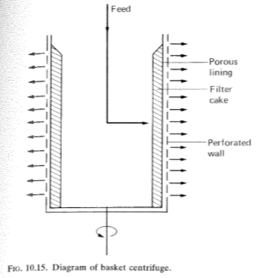

- THE TUBULAR-BOWL CENTRIFUGE
This is a centrifuge to consider using for particle size ranges of 0.1 to 200 µm and up to 10% solids in the in-going slurry. Figure 10.16a shows an arrangement used in a Sharples Super-Centrifuge. The main component of the centrifuge is a cylindrical bowl (or rotor) (A in Fig. 10.16), which may be of a variable design depending on application, suspended by a flexible shaft (B), driven by an overhead motor or air turbine (C). The inlet to the bowl is via a nozzle attached to the bottom bearing (D). The feed which may consist of solids and light and heavy liquid phases is introduced by the nozzle (E). During operation solids sediment on the bowl wall while the liquids separate into the heavy phase in zone (0) and the light phase in the central zone (H). The two liquid phases are kept separate in their exit from the bowl by an adjustable ring, with the heavy phase flowing over the lip of the ring. Rings of various sizes may be fitted for the separation of liquids of various relative densities. Thus the centrifuge may be altered to use for:
(a) Light-phase/heavy-phase liquid separation.
(b) Solids/light-liquid phase/heavy-liquid phase separation.
(c) Solids/liquid separation (using a different rotor, Fig. 10.16(b).
The advantages of this design of centrifuge are the high centrifugal force, good dewatering and ease of cleaning. The disadvantages are limited solids capacity, difficulties in the recovery of collected solids, gradual loss in efficiency as the bowl fills, solids being dislodged from the walls as the bowl is slowing down and foaming. Plastic liners can be used in the bowls to help improve batch cycle time. Alternatively a spare bowl can be changed over in about 5 minutes.
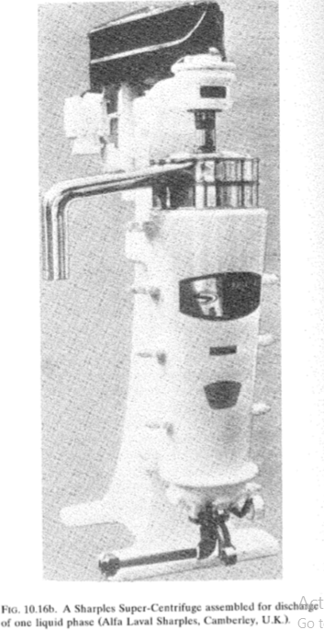
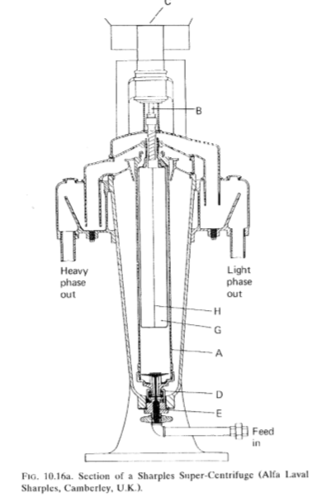

- THE SOLID-BOWL SCROLL CENTRIFUGE (DECANTER CENTRIFUGE)
This type of centrifuge is used for continuous handling of fermentation broths, cell lysates and coarse materials such as sewage sludge (Fig. 10.17). The slurry is fed through the spindle of an archimedean screw within the horizontal rotating solids bowl. Typically the speed differential between the bowl and the screw is in the range 0.5 to 100 rpm (Coulson and Richardson, 1991). The solids settling on the walls of the bowl are scraped to the conical end of the bowl. The slope of the cone helps to remove excess liquid from the solids before discharge. The liquid phase is discharged from the opposite end of the bowl. The speed of this type of centrifuge is limited to around 5000 rpm in larger models because of the lack of balance within the bowl, with smaller models having bowl speeds of up to 10000 rpm. Bowl diameters are normally between 0.2 and 1.5 metres, with the length being up to five times the diameter. Feed rates range from around 200 dm3 h-1 to 200 m3 h-1 depending on scale of operation and material being processed.
A number of variants on the basic design are available:
(a) Cake washing facilities (screen bowl decanters).
(b) Vertical bowl decanters.
(c) Facility for in-place cleaning.
(d) Bio-hazard containment features; steam sterilization in-situ, two or three stage mechanical seals, control of aerosols, containment casings and the use of high pressure sterile gas in seals to prevent the release of microorganisms.
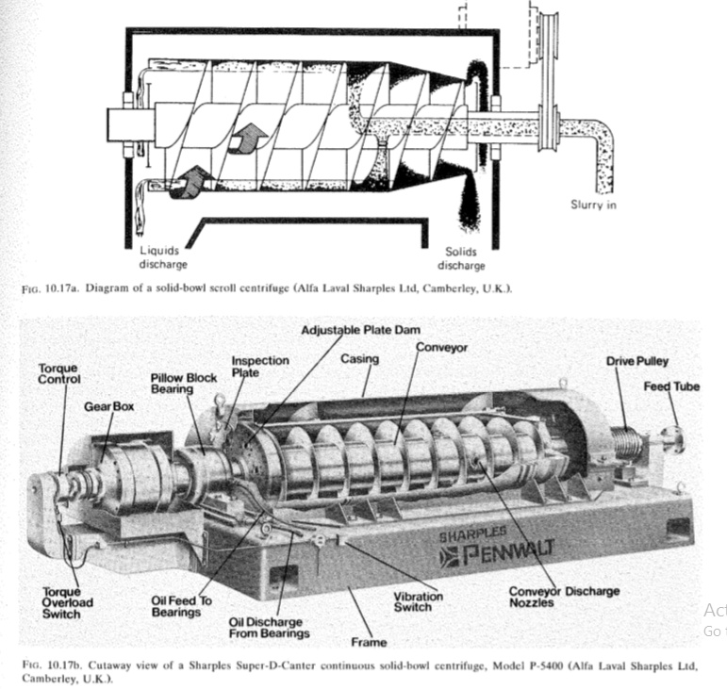

- THE MULTICHAMBER CENTRIFUGE
Ideally, this is a centrifuge for a slurry of up to 5% solids of particle size 0.1 to 200 /-tm diameter. In the multichamber centrifuge (Fig. 10.18), a series of concentric chambers are mounted within the rotor chamber. The broth enters via the central spindle and then takes a circuitous route through the chambers. Solids collect on the outer faces of each chamber. The smaller particles collect in the outer chambers where they are subjected to greater centrifugal forces (the greater the radial position of a particle, the greater the rate of sedimentation). Although these vessels can have a greater solids capacity than tubular bowls and there is no loss of efficiency as the chamber fills with solids, their mechanical strength and design limits their speed to a maximum of 6500 rpm for a rotor 46-cm diameter with a holding capacity of up to 76 dm3. Because of the time needed to dismantle and recover the solids fraction, the size and number of vessels must be of the correct volume for the solids of a batch run.
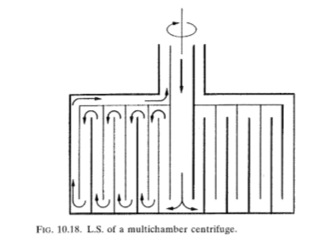

- THE DISC-BOWL CENTRIFUGE
This centrifuge relies for its efficiency on the presence of discs in the rotor or bowl (Fig. 10.19). A central inlet pipe is surrounded by a stack of stainless-steel conical discs. Each disc has spacers so that a stack can be built up. The broth to be separated flows outwards from the central feed pipe, then upwards and inwards between the discs at an angle of 45° to the axis of rotation. The close packing of the discs assists rapid sedimentation and the solids then slide to the edge of the bowl, provided that there are no gums or fats in the slurry, and eventually accumulate on the inner wall of the bowl. Ideally, the sediment should form a sludge which flows, rather than a hard particulate or lumpy sediment.
The main advantages of these centrifuges are their small size compared with a bowl without discs for a given throughput. Some designs also have the facility for continuous solids removal through a series of nozzles in the circumference of the bowl or intermittent solids removal by automatic opening of the solids collection bowl. The arrangement of the discs makes this type of centrifuge laborious to clean
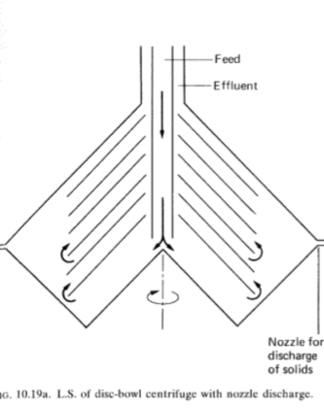
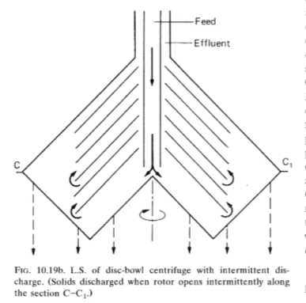

References
- Stanbury, The recovery and purification of fermentation product. Principle of fermentation technology. Second edition. Butterworth-Heinemann

