Chemical mutagens
Base analogs
One class of chemical mutagens consists of base analogs, chemicals with structures similar to that of any of the four standard bases of DNA. DNA polymerases cannot distinguish these analogs from the standard bases; so, if base analogs are present during replication, they may be incorporated into newly synthesized DNA molecules. For example, 5-bromouracil (5BU) is an analog of thymine; it has the same structure as that of thymine except that it has a bromine (Br) atom on the 5-carbon atom instead of a methyl group.
Normally, 5-bromouracil pairs with adenine just as thymine does, but it occasionally mispairs with guanine, leading to a transition (T · A→5BU· A→5BU · G→C · G). Through mispairing, 5-bromouracil can also be incorporated into a newly synthesized DNA strand opposite guanine. In the next round of replication 5-bromouracil pairs with adenine, leading to another transition (G · C→G · 5BU→A · 5BU→A · T).
Another mutagenic chemical is 2-aminopurine (2AP), which is a base analog of adenine. Normally, 2-aminopurine base pairs with thymine, but it may mispair with cytosine, causing a transition mutation (T · A→T · 2AP→C · 2AP→C · G). Alternatively, 2-aminopurine may be incorporated through mispairing into the newly synthesized DNA opposite cytosine and then later pair with thymine, leading to a C · G→C · 2AP→T · 2AP→T · A transition.

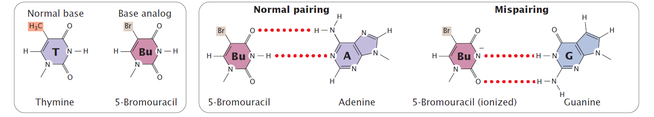

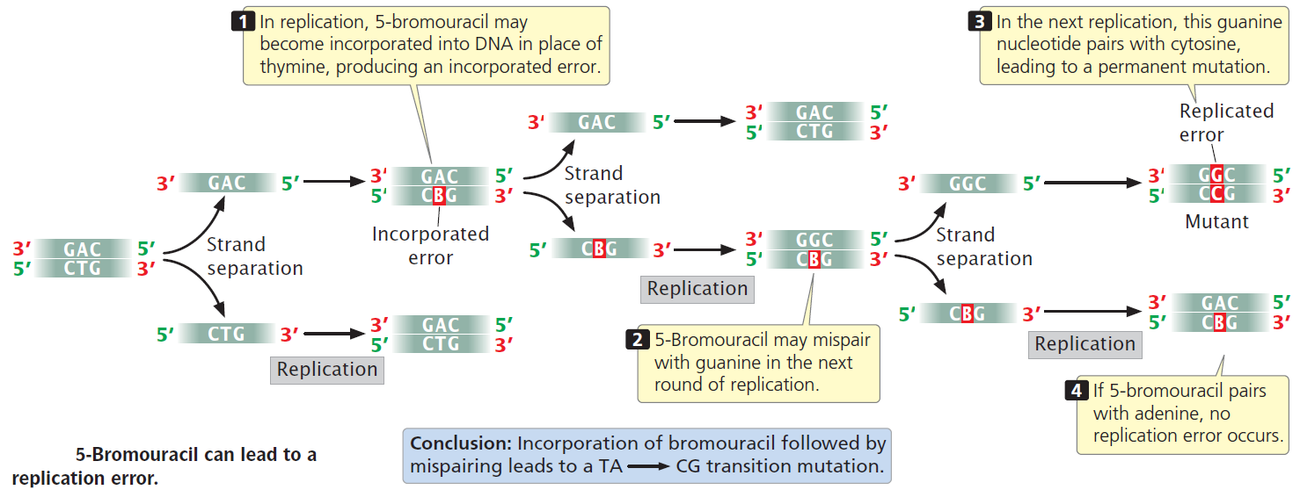

Deaminating agents
Deaminating agents cause point mutations by removal of an amino group from bases. Deamination can be induced by some chemicals. For instance, nitrous acid deaminates cytosine, creating uracil, which in the next round of replication pairs with adenine, producing a C · G→T · A transition mutation. Nitrous acid changes adenine into hypoxanthine, which pairs with cytosine, leading to a T · A→C · G transition. Nitrous acid also deaminates guanine, producing xanthine, which pairs with cytosine just as guanine does; however, xanthine can also pair with thymine, leading to a C · G→T · A transition. Nitrous acid produces exclusively transition mutations and, because both C · G→T · A and T · A→C · G transitions are produced, these mutations can be reversed with nitrous acid.
Alkylating agents
Alkylating agents are chemicals that donate alkyl groups, such as methyl (CH3) and ethyl (CH3–CH2) groups, to nucleotide bases. For example, ethylmethylsulfonate (EMS) adds an ethyl group to guanine, producing O6-ethylguanine, which pairs with thymine. Thus, EMS produces C · G→T · A transitions. EMS is also capable of adding an ethyl group to thymine, producing 4-ethylthymine, which then pairs with guanine, leading to a T · A→C · G transition. Because EMS produces both C · G→T · A and T · A→C · G transitions, mutations produced by EMS can be reversed by additional treatment with EMS.

Hydroxylamine
Hydroxylamine is a very specific base modifying mutagen that adds a hydroxyl group to cytosine, converting it into hydroxylaminocytosine. This conversion increases the frequency of a rare tautomer that pairs with adenine instead of guanine and leads to C · G→T · A transitions. Because hydroxylamine acts only on cytosine, it will not generate T · A→C · G transitions; thus, hydroxylamine will not reverse the mutations that it produces.
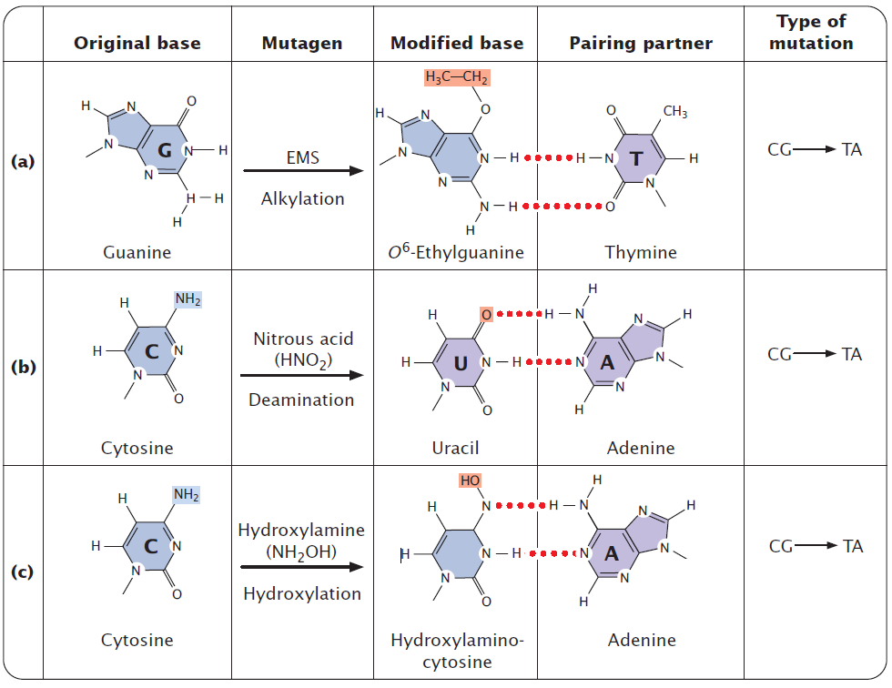
Oxidative reactions
Reactive forms of oxygen (including superoxide radicals, hydrogen peroxide, and hydroxyl radicals) are produced in the course of normal aerobic metabolism, as well as by radiation, ozone, peroxides, and certain drugs. These reactive forms of oxygen damage DNA and induce mutations by bringing about chemical changes in DNA. For example, oxidation converts guanine into 8-oxy-7,8-dihydrodeoxyguanine , which frequently mis pairs with adenine instead of cytosine, causing a G · C→T · A transversion mutation.
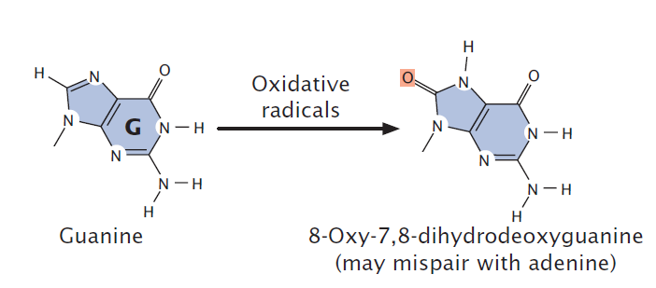

Intercalating agents
Proflavin, acridine orange, ethidium bromide, and dioxin are intercalating agents, which produce mutations by sandwiching themselves (intercalating) between adjacent bases in DNA, distorting the three-dimensional structure of the helix and causing single-nucleotide insertions and deletions in replication. These insertions and deletions frequently produce frameshift mutations, and so the mutagenic effects of intercalating agents are often severe. Because intercalating agents generate both additions and deletions, they can reverse the effects of their own mutations.
