Drying
The drying of any product (including biological products) is often the last stage of a manufacturing process. It involves the final removal of water from a heat-sensitive material ensuring that there is minimum loss in viability, activity or nutritional value. Drying is undertaken because:
(a) The cost of transport can be reduced.
(b) The material is easier to handle and package.
(c) The material can be stored more conveniently in the dry state.
Practice of drying can be performed by Spray drying and Freeze drying or Lyophilization
- Spray drying
A spray drier (Fig. 10.32) is most widely used for drying of biological materials when the starting material is in the form of a liquid or paste. The material to be dried does not come into contact with the heating surfaces, instead, it is atomized into small droplets through for example a nozzle or by contact with a rotating disc.
The droplets then fall into a spiral stream of hot gas at 150° to 250°. The high surface area:volume ratio of the droplets results in a rapid rate of evaporation and complete drying in a few seconds, with drying rate and product size being directly related to droplet size produced by the atomizer.
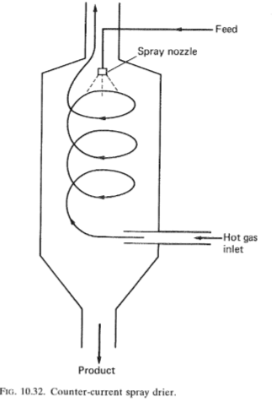
The evaporative cooling effect prevents the material from becoming overheated and damaged. The gas-flow rate must be carefully regulated so that the gas has the capacity to contain required the moisture content at the cool-air exhaust temperature (75° to 100°).

- Freeze drying or lyophilization
Freeze drying is an important operation in the production of many biologicals and pharmaceuticals. The material is first frozen and then dried by sublimation in a high vacuum. The great benefit of this technique is that it does not harm heat sensitive materials. The process is often termed lyophilization when the solvent being evaporated is water.
Fluidized bed driers are used increasingly in the pharmaceutical industry. Heated air is fed into a chamber of fluidized solids, to which wet material is continuously added and dry material continuously removed. Very high mass-transfer rates are achieved, giving rapid evaporation and allowing the whole bed to be maintained in a dry condition.
Reference
- Stanbury, The Recovery and Purification of Fermentation Products, Principles of Fermentation Technology, Second Edition.

