FDDI
FDDI (Fiber Distributed Data Interface) is a high-speed network technology, conforming to the Open Systems Interconnection (OSI) reference model for networking and the American National Standards Institute (ANSI), for data transmission on fiber optic lines in a local area network (LAN) that can extend in range up to 200 km (124 miles), which runs at 100 Mbps over fiber-optic cabling.
The FDDI protocol is based on the token ring protocol.
In addition to being large geographically, an FDDI local area network can support thousands of users. FDDI is frequently used on the backbone for a wide area network.
An FDDI network contains two token rings, one for possible backup in case the primary ring fails. The primary ring offers up to 100 Mbps capacity. If the secondary ring is not needed for backup, it can also carry data, extending capacity to 200 Mbps. The single ring can extend the maximum distance; a dual ring can extend 100 km (62 miles).

How FDDI Works
Fiber Distributed Data Interface (FDDI) is usually implemented as a dual token-passing ring within a ring topology (for campus networks) or star topology (within a building). The dual ring consists of a primary and secondary ring.
The primary ring carries data. The counter-rotating secondary ring can carry data in the opposite direction, but is more commonly reserved as a backup in case the primary ring goes down. This provides FDDI with the degree of fault tolerance necessary for network backbones. In the event of a failure on the primary ring, FDDI automatically reconfigures itself to use the secondary ring. Faults can be located and repaired using a fault isolation technique called beaconing. However, the secondary ring can also be configured for carrying data, extending the maximum potential bandwidth to 200 Mbps.
Stations connect to one (or both) rings using a media interface connector (MIC). Its two fiber ports can be either male or female, depending on the implementation.
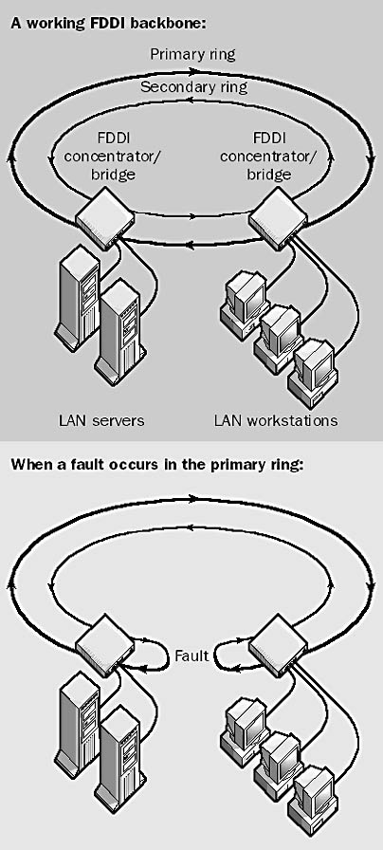
FDDI uses a timed token-passing technology similar to that of token ring networks as defined in the IEEE 802.5 standard. FDDI stations generate a token that controls the sequence in which other stations will gain access to the wire. The token passes around the ring, moving from one node to the next. When a station wants to transmit information, it captures the token, transmits as many frames of information as it wants (within the specified access period), and then releases the token.
There can be up to 500 stations on a dual-ring FDDI network. The maximum circumference for an FDDI ring is 100 kilometers (or 200 kilometers for both rings combined), and there must be a repeater every 2 kilometers or less. Bridges or routers are used to connect the FDDI backbone network to Ethernet or token ring departmental LANs. For these reasons, FDDI is not often used as a wide area network (WAN) solution, but is more often implemented in campus-wide networks as a network backbone.

