What are the Keys in DBMS?

A key is an attribute or a set of attributes that help to uniquely identify a tuple (or row) in a relation (or table). Keys are also used to establish relationships between the different tables and columns of a relational database. Individual values in a key are called key values.

Types of Keys in DBMS
There are broadly seven types of keys in DBMS.

- Primary Key
- Candidate Key
- Super Key
- Foreign Key
- Composite Key
- Alternate Key
- Unique Key

- Primary Key

Primary key is a column of a table or a set of columns that helps to identify every record present in that table uniquely. There can be only one primary Key in a table. Also, the primary Key cannot have the same values repeating for any row. Every value of the primary key must be different with no repetitions.
The PRIMARY KEY (PK) constraint put on a column or set of columns will not allow them to have any null values or any duplicates. One table can have only one primary key constraint.

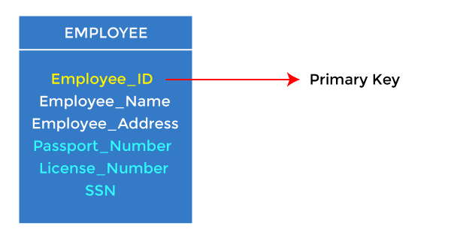
- In the EMPLOYEE table, ID can be the primary key since it is unique for each employee. In the EMPLOYEE table, we can even select License_Number and Passport_Number as primary keys since they are also unique.

- Candidate Key

- A candidate key is an attribute or set of attributes that can uniquely identify a tuple.
- Except for the primary key, the remaining attributes are considered a candidate key. The candidate keys are as strong as the primary key.
For example: In the EMPLOYEE table, id is best suited for the primary key. The rest of the attributes, like SSN, Passport_Number, License_Number, etc., are considered a candidate key.
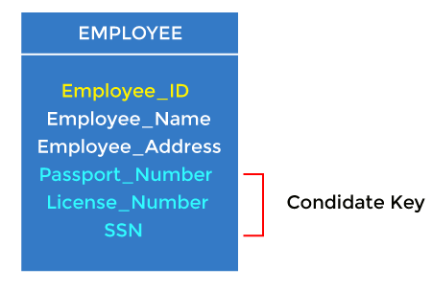
For example: In the EMPLOYEE table, id is best suited for the primary key. The rest of the attributes, like SSN, Passport_Number, License_Number, etc., are considered a candidate key.

- Super Key

Super key is an attribute set that can uniquely identify a tuple. A super key is a superset of a candidate key.

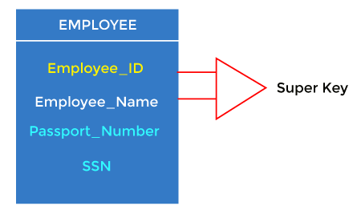
For example: In the above EMPLOYEE table, for(EMPLOEE_ID, EMPLOYEE_NAME), the name of two employees can be the same, but their EMPLYEE_ID can't be the same. Hence, this combination can also be a key.
The super key would be EMPLOYEE-ID (EMPLOYEE_ID, EMPLOYEE-NAME), etc.

- Foreign Key
- Foreign keys are the column of the table used to point to the primary key of another table.
- Every employee works in a specific department in a company, and employee and department are two different entities. So we can't store the department's information in the employee table. That's why we link these two tables through the primary key of one table.
- We add the primary key of the DEPARTMENT table, Department_Id, as a new attribute in the EMPLOYEE table.
- In the EMPLOYEE table, Department_Id is the foreign key, and both the tables are related.
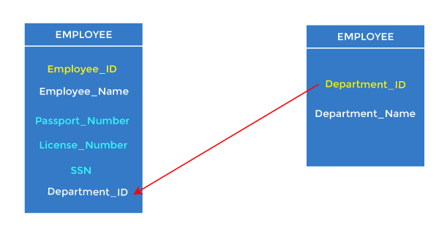

  - Composite Key
- Whenever a primary key consists of more than one attribute, it is known as a composite key. This key is also known as Concatenated Key.
- 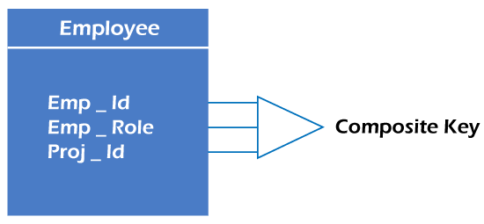
For example, in employee relations, we assume that an employee may be assigned multiple roles, and an employee may work on multiple projects simultaneously. So the primary key will be composed of all three attributes, namely Emp_ID, Emp_role, and Proj_ID in combination. So these attributes act as a composite key since the primary key comprises more than one attribute.

Alternate key
- There may be one or more attributes or a combination of attributes that uniquely identify each tuple in a relation. These attributes or combinations of the attributes are called the candidate keys. One key is chosen as the primary key from these candidate keys, and the remaining candidate key, if it exists, is termed the alternate key. In other words, the total number of the alternate keys is the total number of candidate keys minus the primary key. The alternate key may or may not exist. If there is only one candidate key in a relation, it does not have an alternate key.
- For example, employee relation has two attributes, Employee_Id and PAN_No, that act as candidate keys. In this relation, Employee_Id is chosen as the primary key, so the other candidate key, PAN_No, acts as the Alternate key.
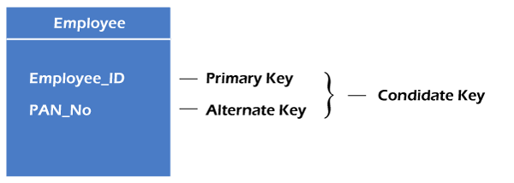

Unique Key

Unique Key is a column or set of columns that uniquely identify each record in a table. All values will have to be unique in this Key. A unique Key differs from a primary key because it can have only one null value, whereas a primary Key cannot have any null values.

