Fosmid
• Fosmids are similar to cosmids, however they are primarily based on bacterial F-plasmid.
• Simon and co-workers, in the year 1992, first developed F-factor based vector named as pFOS for stable propagation of cosmid sized human genomic DNA inserts.
• They carry the F plasmid origin of replication and a λ cos site.
• Fosmids can carry up to 40 kb of insert DNA.
• The cloning vector is limited, as a host (usually E. coli) can only contain one fosmid molecule. Low copy number offers higher stability as compared to high copy number cosmids.
• Fosmids have high structural stability and have been found to maintain human DNA effectively even after 100 generations of growth. It is ideal to use a fosmid vectors for constructing genomic and meta-genomic libraries.
Cloning vectors based on M13 phage
M13 phage-based vector for cloning DNA is especially useful for sequencing of the inserted DNA. This filamentous virus contains 6.4 kb single-stranded circle of DNA. M13 enters E. coli through the bacterial sex pilus, a protein appendage that permits the transfer of DNA between bacteria. The single-stranded DNA in the virus particle [called the (+) strand] is replicated through an intermediate circular double-stranded replicative form (RF) containing (+) and (-) strands. Only the (+) strand is packaged into new virus particles.
About a thousand progeny M13 are produced per generation. M13 does not kill its bacterial host. Consequently, large quantities of M13 can be grown and easily harvested.
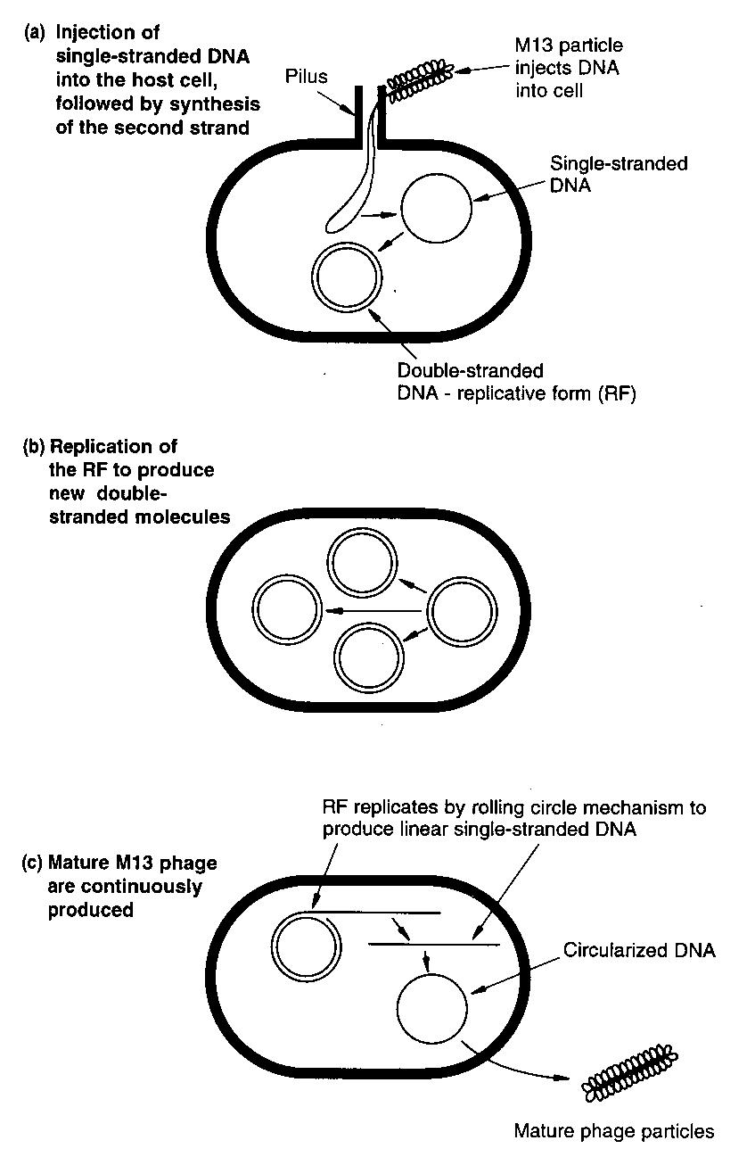
Fig: Infection cycle of bacteriophage M13
The first step in the construction of an M13 cloning vector was to introduce the lacZ’ gene into the intergenic sequence. This gave rise to M13 mp1 which forms blue plaques on x-gal Agar. poly linkers were then inserted into the lacZ’ gene to create a series of M13 vectors with different sets of cloning sites. The poly linkers are the same as those used in the PUC plasmids which means that the cloned DNA can be started between the equivalent M13 and pUC vectors so that single and double stranded versions can be obtained.

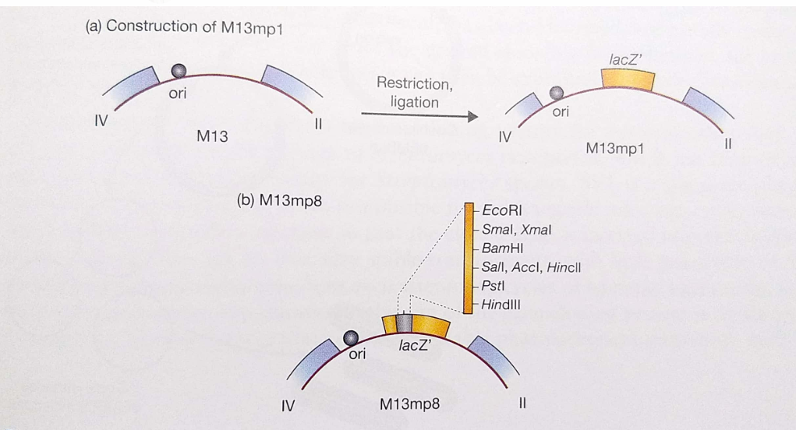

An M13 vector is prepared for cloning by cutting its circular RF DNA at single site with a restriction enzyme. The cut is made in a polylinker region that contains a series of closely spaced recognition sites for restriction enzymes; only one of each such sites is present in the vector. A double-stranded foreign DNA fragment produced by cleavage with same restriction enzyme is then ligated to the cut vector. The foreign DNA can be inserted in two different orientations because the ends of both DNA molecules are the same. Hence, half the new (+) strands packaged into virus particles will contain one of the strands of the foreign DNA, and half will contain the other strand. Infection of the E. coli by a single virus particle will yield a large amount of single-stranded M13 DNA containing the same strand of the foreign DNA. DNA cloned into M13 can be easily sequenced.
Phagemid
Although M13 vectors are very useful for the production of single-stranded recombinant genes, they have certain disadvantages. There is a limit to the size of DNA fragment that can be cloned in an M13vector, with 1.5 kb being the ideal capacity, although fragments up to 3 kb have occasionally been cloned. To overcome this limitation, phagemid vectors were developed by combining a part of the M13 genome with plasmid DNA.
• Phagemids are cloning vectors developed as a hybrid of the filamentous phage M13 and plasmids to produce a vector that can get packed as a phage particle but also can propagate as a plasmid.
• They contain an origin of replication (ori) for double stranded replication inside E. coli host, as well as an “f1 ori” to enable single stranded replication and packaging into phage particles. Many commonly used plasmids contain an f1 ori and are thus phagemids.
• Phagemid generally encode no or only one of the capsid proteins of virus. Other structural and functional proteins necessary for phage lifecycle are provided by the helper phage.
• The components present in a phagemid vector are:
  - Origin of replication (ori) of a plasmid.
  - Intergenic region (IG region) which contains the packaging signal for the phage particle and also has replication origin inside phage.
  - A gene encoding phage coat protein.
  - A selection marker.
  - Restriction enzyme recognition sites.

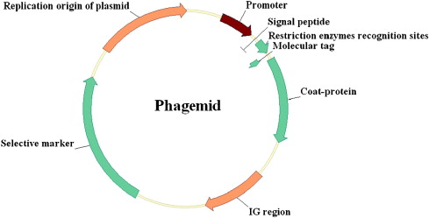
An example of phagemid is provided by pEMBL8, which was made by transferring a 1300bp fragment of the M13 genome into pUC8.
This piece of M13 DNA contains the single sequence recognized by the enzymes that convert the normal double stranded M13 molecule into single stranded DNA before the secretion of new page particles.
This signal sequence is still functional even though detached from the rest of the M13 genome so pEMBL8 molecules are also converted into single stranded DNA and secreted as defective phage particles.
The E. coli used as host for a pEMBL8 cloning experiment are subsequently infected with normal M13 to act as a helper phage, providing the necessary replicate Avenger science and fast code proteins. pEMBL8, being derived from pUC8, has a polylinker cloning site within the lacZ gene so recombinant plaques can be identified in the standard way on Agar containing X-gal.
With pEMBL8, single stranded versions of the cloned DNA fragments up to 10 KB in length can be obtained, greatly extending the range of the M13 cloning system.
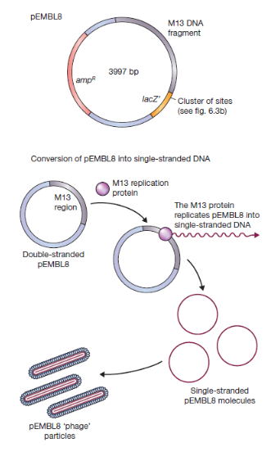

References
- Gene cloning & DNA analysis by T. A. Brown
- Life sciences by Pranav Kumar and Usha Mina (Pathfinder publication)

