Meat
Meat is the most valuable livestock product. Meat is composed of protein and amino acids, minerals, fats and fatty acids, vitamins and other bioactive components, and small quantities of carbohydrates. From the nutritional point of view, meat’s importance is derived from its high quality protein, containing all essential amino acids and it’s highly bioavailable minerals and vitamins.
Meat fermentation is a low energy preservation method, which results in unique and distinctive properties in meat such as flavour and palatability, colour, microbiological safety, tenderness and a host of other desirable properties of this specialized meat.
A raw meat is often converted to fermented product by inoculation of cultured or wild microorganisms which lower the pH. Lactic acid accounts for the antimicrobial properties of fermented meat (Fig 2). This originates from the natural conversion of glycogen reserves in the meat and the added sugar during product fermentation. The acidification of the finished product upon addition of lactic acid and addition of salt which also lowers water activity on drying is the crux of fermentation. Both natural and controlled fermentations involve lactic acid bacteria.
Meat Fermentation Process
Most starter cultures, used today, consist of lactic acid bacteria and/or micrococci, selected for their metabolic activity which often improves flavour development. The reduction of pH and lowering of water activity are microbial hurdles in producing a safe product. Fermented sausages often have a long storage life due to added salt, nitrite, and/or nitrate, low pH due to lactic acid production by lactic acid bacteria organisms in the early stages of storage, and later drying which reduces the water activity.
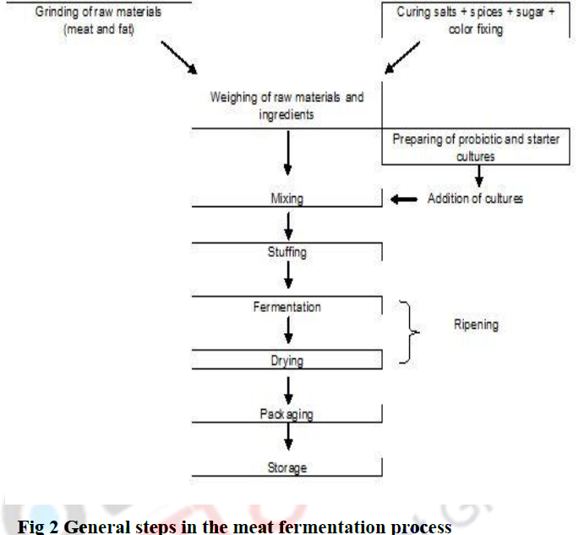

Fermented sausages perhaps originated in the Mediterranean region during Roman period. Some products like Salami Milanese and Hungarian Salami have succeeded for centuries and are till now day being consumed. The process of fermentation was carried out throughout centuries without any scientific information regarding the nature of the processes involved in the fermentation of meat products. Recently, sausage-manufacturer would transfer old curing brine to the newly-prepared one. As a result novel brine would become inoculated with useful micro-organisms, causing the important changes in the cured meat at the time of ripening. This conventional process was depended on practical observations without the information of bacteriology So, the results were not forever acceptable.
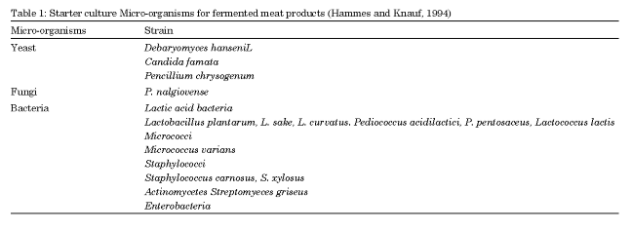
Starter culture for meat fermentation: Hammes and Knauf (1994) defines the meat starter cultures as the “preparations that include living or inactive micro-organism that build up the desired metabolic activity in the meat”. As an act, they are of facultative hetero fermentative strains of micro-organisms which form lactic acid from hexose sugars, for e.g., glucose and lactose as their metabolic products (via glycolysis). Though, from pentose, such as arabinose and xylose they formed both lactic acid as well as acetic acid (through the 6-phasphogluconate/phasphoketolase pathway). The formation of the amount of acetic acid is typically 1/10th of the amount of lactic acid. As designated in industrial catalogues of Lactic Acid Bacteria (LBA) strains, most of the meat starter cultures are Lactobacillus pentosus, L. casei L. curvetus, L. planterum, L. sakei, Pediococcus acidilactici, P. pentosaceus. Starter culture Micro-organisms for Fermented Meat products are presented in Table 1. Table 2 shows the role of microorganisms in meat fermentation.
Role of microorganisms in meat fermentation
Among the starter lactic acid bacteria, Lactobacillus brevis, L.planatarum, L.ferementum and Pedioccus pentosaceus have been characterized as probiotics. Strains of L.sakei and P.acidilactici have also been proposed as potential probiotic in meat products. Probiotic cultures can also be selected from the lactic acid bacteria in fermented meat products. Facultative or obligate anaerobes which belong to the Gram-positive acid forming bacteria (primarily lactic acid) such as the genera Lactobacillus, Streptococcus, Pediococcus, Leuconostoc, Lactococcus and Enterococcus are used which can metabolize several saccharides into lactic acid, alcohols, aliphatic compounds, lipids and some amino acids. These organisms perform two functions in fermented sausages: reducing nitrate and nitrite into nitric oxide and when combined with myoglobin is responsible for cured colour, and by anaerobic glycolysis to produce lactic acid from glucose which reduces the pH.
The sterile tissues of animals on slaughtering become contaminated by spoilage and pathogenic Gram-negative bacteria such as E.coli, Salmonella species, Pseudomonas sp. and Closteridium periferigens and also Gram-positive species. As a measure of preservation of meat, its water activity (aw) is reduced by adding salt or curing by the addition of nitrite or drying. Acid fermentation of meat is carried out to enhance the stability, texture, colour and flavour of the product by choosing appropriate starter cultures.
In the manufacture of fermented meat products, starter cultures mainly of Pediococcus cervisiae, Lactoobacillus planatarum and Micrococcus are used. The majority of fermented products may be classified into dry sausages with a moisture content of 25 to 45% (aw ~0.91) and semi-dry sausages with a moisture content of 50% (a_{w} 0.95). Meat curing compounds and starter culture are mixed and stuffed in casings at low temperature of about - 5°C and incubated at a temperature between 20 and 40°C for fermentation. The fermented product is dried at 10-20°C.
Examples of dry fermented meat sausages include pepperoni and salami while bologna and summer sausages are semi dried fermented meat sausages. Fermented poultry sausages include dry as well as semi-dry turkey sausages.

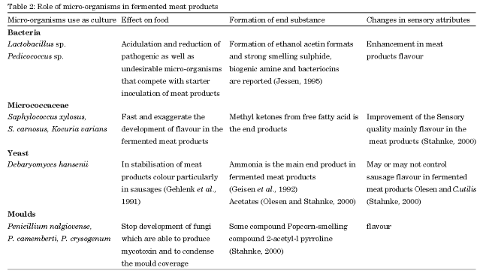
Reference
- Singh V.P., Pathak V. and Verma Akhilesh K. (2012), Fermented Meat Products: Organoleptic Qualities and Biogenic Amines-a Review, “American Journal of Food
Technology” 7 (5): 278-288

