Succession- the development of the community by the action of vegetation on the environment leading to the establishment of new species is termed succession. Succession is the universal process of changes in vegetation during ecological time. So, we can say microbial succession is the sequential event of mesophilic and thermophilic prokaryotes in composting plant organic matter.
Decomposition and Humification- A central process in the life cycle of all organisms is the decomposition of their dead remains. Plants are no exception to it. Truly speaking, a significant proportion of the net primary production in the biosphere, especially in the terrestrial ecosystems, ends up as accumulations of dead remains of plants at soil surface or below it. These dead remains get decomposed; and the nutrients locked up in the litter as well as a number of new substances formed in the process of decomposition, pass down the soil profile. The significance of this process was recognized long ago. One may find references to "humus" and its importance in increasing soil fertility, it is basically a biological one resulting from the diverse activities of microorganisms, protozoa and various other soil organisms like insects and worms.
Plant litter decomposition and microorganisms- The fungi play a "predominant" role in the decomposition of plant litter, is now a well-established fact. It is now realised that the plant litter is decomposed by a sequence of events involving physical processes like leaching and mechanical breakdown; as well as through biological processes like microbial degradation which involve several exo-enzymes. In aerobic environments, the saprobic fungi which can secrete cellulases and other exo-enzymes directly into the environment constitute a major group amongst the decomposer community.
Succession of decomposers: Earlier studies on soil fungi were mainly concerned with the compilation of floristic lists. However, gradually the emphasis shifted on studying the ecology of soil mycobiota. The synecological studies led to a survey of substrate relationships of these fungi. Garrett suggested that it is the root-infecting fungi which open the way for a sequence of saprophytic 'sugar fungi', cellulose-decomposers and finally lignin-decomposers in the invaded tissue. Later on, Garrett proposed the following very generalised scheme for the succession of fungi on a corpus of plant tissue lying within or upon the soil.
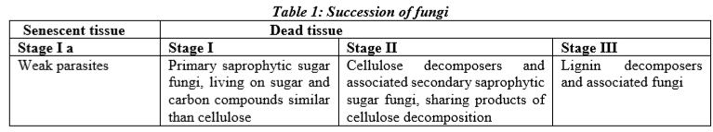 In this scheme, Garrett recognized a 'secondary group' of 'sugar fungi' which do not live on simple carbon sources initially present in the fresh plant tissue, but are dependent upon the hydrolytic products of cellulose-decomposing fungi; and, therefore, appear late in succession in association of these. One of the features that led to the development of substrate-group hypothesis was the observation that the initial rates of losses of different components could be clearly ranked: Sugar > Hemicellulose > Cellulose > Lignin. During this succession, the substrates were found to become progressively depleted, beginning with sugars and the simpler carbon compounds, continuing with cellulose; and finally with lignin. The Phycomycetes (no more recognised as a taxonomic group) came to be considered as 'sugar fungi' par excellence; the Ascomycetes and Fungi Imperfecti as cellulolytic; the decomposition of lignin was believed to be primarily the work of the higher Basidiomycetes.
On other substrates, the pattern of succession appears to be one or several waves of Ascomycetes and Fungi Imperfecti following each other. In fact, Chesters, embarked upon the idea that the aerial parts of "plant shoot systems are worked over" by weak parasitic and saprobic species, and they arrive at the soil surface much depleted of their nutritional possibilities. Kendrick, found initial colonization of pine litter by weak parasites. The studies of the saprobic mycobiota of Saccharum officinarum by Hudson revealed a primary fungal biota consisting of a number of weak parasites and saprobes followed by Periconiella and some imperfect fungi; and finally by numerous imperfect fungi and Ascomycetes. More or less similar pattern was observed by Hogg on leaves of Fagus sylvatica; Singh and Charaya, on wheat crop resedue, Hudson, suggested that for many types of leaf and herbaceous litters, some general correspondence of pattern could be discerned in the observed changes. He proposed the following scheme for the succession of fungi on most plant debris except the lignicolous ones:
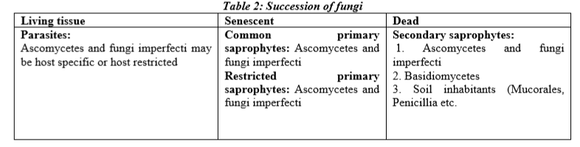
Ruscoe, found that the leaves of Nothofagus truncatus were already heavily colonized by a variety of parasitic and saprobic fungi when they reached the forest floor. Tubaki and Yokoyam, studied the succession on the leaves of Castanopsis cuspidata and Quercus phyllyraeoides.
Overall how decomposition of plant organic matter by succession of microbial communities—(i) A group of early colonizers comprising the transient fungi, present on the leaf surface only as detachable propagules, (ii) fungi growing and sporulating actively through out the decay period; and (iii) a group found early in the decay process, but disappearing later; and (iv) a group found at late stages.
The study, thus, suggested that the pattern of colonization of a substrate by the mycoflora is largely regulated by the nature of the resource itself. The mycoflora naturally occurring on plant organic matter play a vital role in decomposition of plant organic matter by the pattern of successive colonization.
Conclusion - The urbanization and industrialization responsible for hudge amount of solid wastes including plant litters and house hold organic wastes, causes environmental problems. Microbes are able to degrade such type of lignocellulosic wastes convert them into products of social welfare such as biogas, enzymes, organic acids etc. This study analysis the biochemical and taxonomic succession of fungi of decomposing plant litters. It is helpful to decide the pattern of colonization of substrates by decomposers and to develop a microbial technology for lignocellulosic waste recycling for safe and clean environment.
Reference
- Dr. P.S. Verma, Cell Biology, Genetics, Molecular Biology, Evolution and Ecology, Fourteen Edition.
- Singh Raj, Rani Anju, Kumar Permod, Shukla Gyanika, Kumar Amit (2016),The Decomposer Microorganisms In The Environment And Their Succession Of Substrates, International Journal of Engineering Sciences & Research Technology 5(7): 2277-9655

